Session | 2024-25 (ODD) |  | Course Name | Web Technology Lab
Semester | 3 |  | Course Code | 23CT1301
Roll No | 43 |  | Name of Student | Chetan M Bobde
Practical Number |  | 7
Course Outcome |  | - Understand various internet technologies.  - Design the web pages using HTML and CSS.  - Implement the XML technology to store the data.  - Develop the interactive web pages using JavaScript.
Aim |  | [A] Write a program in JavaScript to perform arithmetic operations.  [B] Write a Program in JavaScript to create Dialogue Boxes.
Problem Definition |  | [A]Write a JavaScript program to take two numbers from the user and perform basic arithmetic operations like addition, subtraction, multiplication, and division.  [B] Write a JavaScript program to show different dialogue boxes like Alert, Confirm, and Prompt to interact with the user.
Theory  (100 words) |  | JavaScript is a high-level scripting language mainly used for creating dynamic and interactive web pages. It runs on the client side within the web browser and adds behavior to HTML elements. One of the important uses of JavaScript is performing arithmetic operations, which are essential in many applications like calculators, billing systems, and data processing programs. JavaScript provides arithmetic operators such as addition (+), subtraction (−), multiplication (*), division (/), and modulus (%), which returns the remainder after division. These operators work on numeric values stored in variables and help perform calculations. Compound operators like += and -= make operations more efficient. JavaScript follows standard mathematical precedence rules, but parentheses can be used to alter the order of execution. Sometimes JavaScript performs automatic type conversion, so programmers must be careful when working with numerical and string data. The results of arithmetic operations can be displayed using document.write(), console.log(), or by updating HTML elements. Along with arithmetic features, JavaScript also allows user interaction through dialogue boxes. Dialogue boxes are simple pop-up windows used to communicate messages or obtain input from users. JavaScript provides three main types of dialog boxes: alert(), prompt(), and confirm(). An Alert Box displays an informational message and contains only an OK button, usually used to warn or notify users. A Prompt Box allows users to input text and returns the entered value, making it useful for collecting data like name or number. A Confirm Box asks for user confirmation with OK and Cancel options and returns true if OK is clicked and false otherwise, commonly used before performing important actions such as deleting data. These dialogue boxes are modal in nature, meaning the browser pauses other actions until the user responds. Though their design cannot be heavily customized because they are controlled by the browser, they remain very effective for simple interactions. JavaScript is event-driven, and these boxes are triggered based on user actions such as button clicks. Arithmetic operations and dialog boxes can be combined, for example, taking two numbers from users using prompt() and displaying the result using alert(). By validating user inputs on the client side, JavaScript helps reduce server load and improves performance. It is platform independent, works on all major browsers, and integrates smoothly with HTML and CSS. JavaScript supports both procedural and object-oriented programming, making it powerful and flexible. Learning arithmetic operations builds problem-solving skills, while interaction through dialog boxes teaches communication between user and webpage. These fundamental concepts form the foundation of modern web development and lead to building advanced interactive and responsive applications. Therefore, understanding JavaScript arithmetic operations and dialogue boxes is essential for beginners to create better user-friendly web experiences.
Procedure and Execution  (100 Words) |  | Step for Implementation:  [A]  1. Create an HTML structure for the calculator layout.  2. Design the calculator using CSS (buttons, display, and layout).  3. Use JavaScript to handle button clicks and display values.  4. Implement a calculate() function to perform operations using eval().  5. Add clearDisplay() to reset the calculator.  6. Test all buttons for correct functionality and handle errors using try-catch.  [B]  1. Create an HTML page with buttons for Alert, Confirm, and Prompt.  2. Add CSS to style the buttons and output area.  3. Write JavaScript functions for each dialog box (showAlert(), showConfirm(), showPrompt()).  4. Use alert() for displaying messages, confirm() for Yes/No, and prompt() for user input.  5. Display the result or user response dynamically using innerText.  6. Test each button to ensure it works correctly.
Code:

[A]
<!DOCTYPE html>
<html lang="en">
<head>
<meta charset="UTF-8">
<meta name="viewport" content="width=device-width, initial-scale=1.0">
<title>Simple Calculator</title>
<style>
body {
display: flex;
justify-content: center;
align-items: center;
height: 100vh;
background: white;
font-family: Arial, sans-serif;
}
.calculator {
background:black;
padding: 20px;
border-radius: 15px;
box-shadow: 0 5px 15px rgba(0,0,0,0.4);
width: 280px;
}
.display {
background:black;
color: green;
font-size: 2em;
text-align: right;
padding: 10px;
border-radius: 10px;
margin-bottom: 15px;
overflow-x: auto;
}
.buttons {
display: grid;
grid-template-columns: repeat(4, 1fr);
gap: 10px;
}
button {
padding: 20px;
font-size: 1.2em;
border: none;
border-radius: 10px;
cursor: pointer;
background: burlywood;
color: white;
transition: 0.2s;
}
button:hover {
background: slategrey;
}
.operator {
background: orange;
}
.operator:hover {
background: orange;
}
.equal {
grid-column: span 2;
background:green;
}
.equal:hover {
background:green;
}
.clear {
background: red;
}
.clear:hover {
background: red;
}
</style>
</head>
<body>
<div class="calculator">
<div class="display" id="display">0</div>
<div class="buttons">
<button class="clear" onclick="clearDisplay()">C</button>
<button onclick="appendValue('/')">÷</button>
<button onclick="appendValue('*')">×</button>
<button onclick="appendValue('-')">-</button>

<button onclick="appendValue('7')">7</button>
<button onclick="appendValue('8')">8</button>
<button onclick="appendValue('9')">9</button>
<button class="operator" onclick="appendValue('+')">+</button>

<button onclick="appendValue('4')">4</button>
<button onclick="appendValue('5')">5</button>
<button onclick="appendValue('6')">6</button>
<button onclick="appendValue('.')">.</button>

<button onclick="appendValue('1')">1</button>
<button onclick="appendValue('2')">2</button>
<button onclick="appendValue('3')">3</button>
<button class="equal" onclick="calculate()">=</button>

<button style="grid-column: span 2;" onclick="appendValue('0')">0</button>
</div>
</div>

<script>
let display = document.getElementById("display");

function appendValue(val) {
if (display.innerText === "0" && val !== ".") {
display.innerText = val;
} else {
display.innerText += val;
}
}

function clearDisplay() {
display.innerText = "0";
}

function calculate() {
try {
display.innerText = eval(display.innerText);
} catch {
display.innerText = "Error";
}
}
</script>
</body>
</html>
[B]

<!DOCTYPE html>
<html lang="en">
<head>
<meta charset="UTF-8">
<meta name="viewport" content="width=device-width, initial-scale=1.0">
<title>JavaScript Dialog Boxes</title>
<style>
body {
font-family: Arial, sans-serif;
background: #f5f5f5;
display: flex;
justify-content: center;
align-items: center;
height: 100vh;
}
.container {
background: #fff;
padding: 20px;
border-radius: 12px;
box-shadow: 0 5px 15px rgba(0,0,0,0.3);
text-align: center;
}
button {
margin: 10px;
padding: 12px 20px;
font-size: 16px;
border: none;
border-radius: 8px;
cursor: pointer;
background: #007bff;
color: white;
transition: 0.2s;
}
button:hover {
background: #0056b3;
}
#output {
margin-top: 15px;
font-weight: bold;
color: #333;
}
</style>
</head>
<body>
<div class="container">
<h2>JavaScript Dialog Boxes</h2>
<button onclick="showAlert()">Show Alert</button>
<button onclick="showConfirm()">Show Confirm</button>
<button onclick="showPrompt()">Show Prompt</button>
<div id="output"></div>
</div>

<script>
function showAlert() {
alert("This is a simple alert dialog box!");
}

function showConfirm() {
let result = confirm("Do you like JavaScript?");
document.getElementById("output").innerText = result
? "You clicked OK "
: "You clicked Cancel ";
}

function showPrompt() {
let name = prompt("What is your name?");
if (name) {
document.getElementById("output").innerText = "Hello, " + name + " ";
} else {
document.getElementById("output").innerText = "You didn’t enter anything!";
}
}
</script>
</body>
</html>

Output:
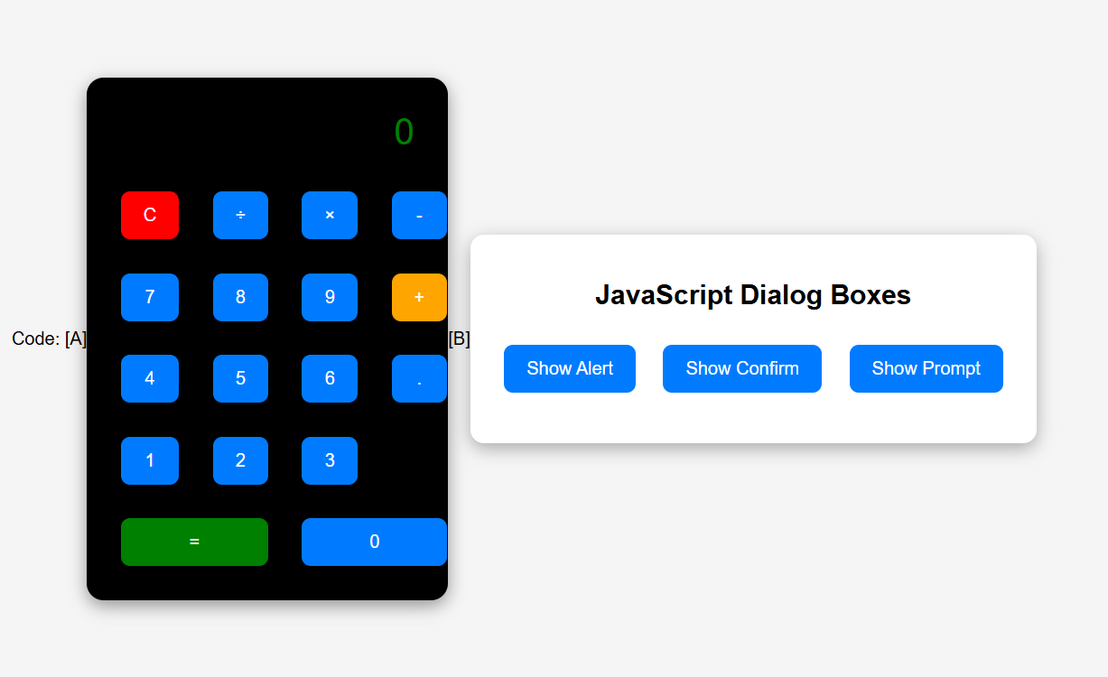
Output Analysis |  | [A]  The calculator takes input through buttons. On pressing numbers and operators, the expression appears on the display. When the “=” button is clicked, the correct result is shown. “C” clears the screen.  [B]  Alert Box: Displays a message “This is a simple alert dialog box!”  Confirm Box: Shows “Do you like JavaScript?” and prints the result based on user choice (OK/Cancel).  Prompt Box: Asks for user’s name and displays a greeting message.
Link of student Github profile where lab assignment has been uploaded |  | chetanbob999/Web-technology-
Conclusion |  | In this practical, we learned how JavaScript is used to perform arithmetic operations and how dialog boxes enhance user interaction on a webpage. Arithmetic operators help in handling mathematical calculations easily, while alert(), prompt() and confirm() methods allow communication between the browser and the user. By executing the program in a web browser, we observed the output results and user responses in real-time. This experiment helped us understand the importance of JavaScript in creating dynamic, interactive, and user-friendly web applications.
Plag Report (Similarity index < 12%) |  | 9%
Date |  | 13/10/2025

